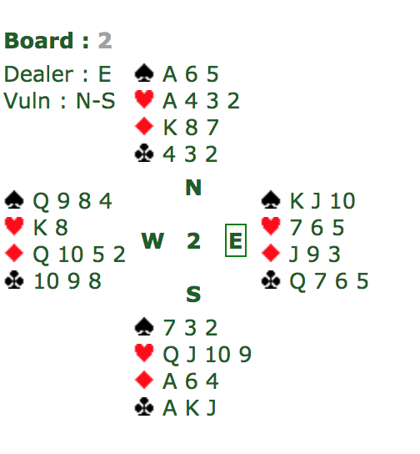

The theme of the first hand of the night is “finessing”. On this hand North-South have 26 points between them the best contract is 3NT. The auction would go 1NT-2C (Stayman) – 2H – 4H with East-West passing throughout. This puts West on lead. The key to this hand is to finesse both hearts AND clubs. If the lead is a spade, win it in dummy and play a club to the jack, finessing the club. Then play the QH finessing the hearts. If West plays low to the QH, play low from dummy. West will be forced to play the KH on the next round of hearts and you can take it with the A. In the end, you should take 4 hearts, 2 diamonds, 3 clubs, and 1 spade for 10 tricks.
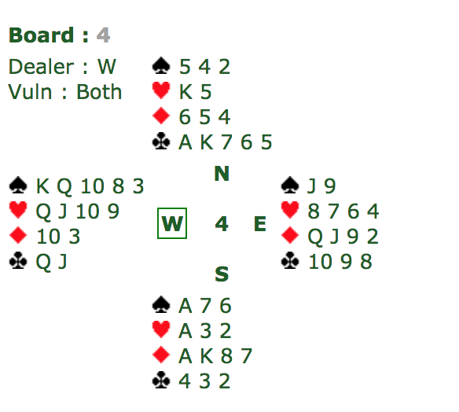

The theme of the second hand is “patience”. North-South have 25 points here, enough for game. The best game for the two hands is 3NT. The bidding will likely go with 1NT by South – 3NT by North. West will lead the K of spades. South should be scared that West will be able to take 4 spade tricks after the Ace of spades is gone. If South takes the AS at trick one and tries to set up clubs, then East can lead back a spade when he gets in. Therefore, South must hold up or not take the first spade trick. When South takes the second spade and then plays 3 clubs (A, K, then little) to set up the last two clubs, East can no longer return a spade. South can win whatever East returns and take 4 clubs, 2 diamonds, 2 hearts, and 1 spade for 9 tricks.

